Chapter 2

**Medical Image techniques:**

* X-ray Imaging: Uses special waves to see inside the body by noticing how much they're absorbed. It shows differences between tissues.
* Magnetic Resonance Imaging (MRI): Uses magnets to see what things are made of and how they work. It's like taking a detailed picture of the body's insides.
* Ultrasound Imaging: Uses sound waves to make pictures of the body. It's like seeing shapes with sound.
* Nuclear Imaging: Uses a special material to see how organs and tissues are doing. It shows where things are active.

**Image Types:**

1. Projection Images:

- Show a projection of the 3D human body onto a 2D plane.

- Provide an overall view but lack depth information.

2. Slice Images:

- Show a distribution of measurement values in a 2D slice through the human body.

- Offer detailed information about a specific plane.

**X-rays:**

* X-ray Production: X-rays are created when high-energy electrons strike a metal target inside a machine called a cathode ray tube. These X-rays are a type of electromagnetic radiation.
* Interaction with Matter: X-rays interact differently with materials in the body. Dense materials, like bones with high atomic numbers, absorb more X-rays, while softer tissues allow more X-rays to pass through.
* Bone Imaging: X-rays are commonly used to visualize bones because they are good at highlighting dense structures. This helps doctors assess bone health and detect fractures or abnormalities.
* CT Scans: CT scans combine X-ray technology with advanced computer processing. They take X-ray images from many different angles around the body, which a computer then uses to create detailed cross-sectional images.
* Medical Diagnosis: Doctors use X-rays and CT scans to diagnose a wide range of medical conditions, from broken bones to internal injuries, by examining the images produced and identifying any abnormalities.
* Exposure: Exposure refers to the amount of radiation received by a person. X-rays release electrons from atoms and are measured in Roentgen (R). Absorption of radiation by the body is measured in rad or gray (Gy). Bones absorb more than soft tissues.
* Imaging Equipment: X-ray machines emit X-rays through a tube and capture them with receptors like film or digital detectors.
* Image Receptors: Image receptors can be film, image intensifiers, or digital flat panel detectors. They capture X-rays and produce images for diagnosis.
* Resolution and Adjustability: Digital radiography offers adjustable resolution without changing exposure.

**Fluoroscopy and Angiography:**

- Fluoroscopy: Visualizes moving objects in the body, such as the heartbeat or contrast agent flow, in real-time.

Angiography: Images blood vessels using contrast agents, assisting in surgical interventions.

Digital Fluoroscopy: Enables real-time imaging and 3D reconstruction, enhancing diagnostic capabilities.

Digital Subtraction Angiography (DSA): Removes non-vascular structures from images, improving clarity and aiding in the assessment of blood vessels.

Digital Techniques: Reduce motion artifacts and enhance image quality, providing more accurate diagnostic information.

**Mammography:**

- Mammography detects breast lesions using specialized X-ray tubes.

- Mammography tubes use low-energy beams to enhance tissue contrast.

- Digital mammography offers advantages like higher dynamic range and easier distribution.

**Computed Tomography (CT):**

- CT reconstructs 3D images from X-ray projections, improving resolution and reducing artifacts.

- Images are computed from projection measurements, allowing detailed 3D visualization.

- Hounsfield units normalize attenuation coefficients for standardized image interpretation.

**Contrast Enhancement in CT:**

- Contrast agents enhance structures in CT scans, especially blood vessels.

- CT angiography (CTA) provides 3D images for quantitative analysis.

- CTA requires higher X-ray exposure but provides detailed soft tissue information.

**Image Analysis on X-ray Generated Images:**

- Radiographs have high spatial resolution for detecting small lesions.

- Assignments between brightness and tissue type are limited.

- Motion and exposure issues can reduce contrast and cause blurring.

- CT images have lower spatial resolution but offer improved 3D visualization.

**Magnetic Resonance Imaging (MRI):**

- Protons and neutrons in atom nuclei possess spin, forming the basis of MRI.

- MRI aligns nuclei spins in a magnetic field and uses radio signals to create images based on spin properties.

- MRI provides excellent soft tissue contrast due to variation in hydrogen density and molecular binding.

- MRI does not use ionizing radiation, offers versatile slice orientations, and can image various functional attributes.

**MRI Basics:**

- MRI uses static magnetic fields measured in Tesla (T) or Gauss.

- Higher magnetic fields increase signal sensitivity.

- Spin frequency depends on magnetic field strength and gyromagnetic constant.

- Exciting proton spins in specific locations using gradient fields allows for slice selection in MRI.

**k-space Imaging:**

MRI Technique: MRI (Magnetic Resonance Imaging) utilizes k-space imaging to create images directly in frequency space.

Gradient Usage: Phase encoding and frequency encoding gradients are employed to dephase spins and measure signal frequency, respectively.

Data Collection: k-space is filled with measured data acquired through these gradients.

Image Reconstruction: The collected data in k-space is then transformed back into the spatial domain, generating detailed images for diagnosis.

**MRI Imaging Vs CT:**

- MRI equipment resembles CT, but MRI gantries are usually smaller.

- MRI can produce images in arbitrary planes and various sequences to enhance tissue contrast.

- Different MRI sequences alter the appearance of tissues based on parameters like spin density and relaxation times (T1, T2).

- MRI does not have a normalized scale like Hounsfield units in CT.

**Some MR Sequences:**

- T1 and T2 relaxation time constants influence image contrast in MRI.

- Spin echo sequence cancels out T2* effects, producing T2-weighted images.

- Inversion recovery sequence heavily influences T1 time constant for image contrast.

- MRI head images typically have 1-3 mm slice thickness with 256x256 or 512x512 voxels per slice.

- Turbo spin echo sequences (RARE) speed up image acquisition by making multiple measurements at once.

- Fast imaging techniques like Echo Planar Imaging (EPI) acquire complete k-space in a single resonance experiment. 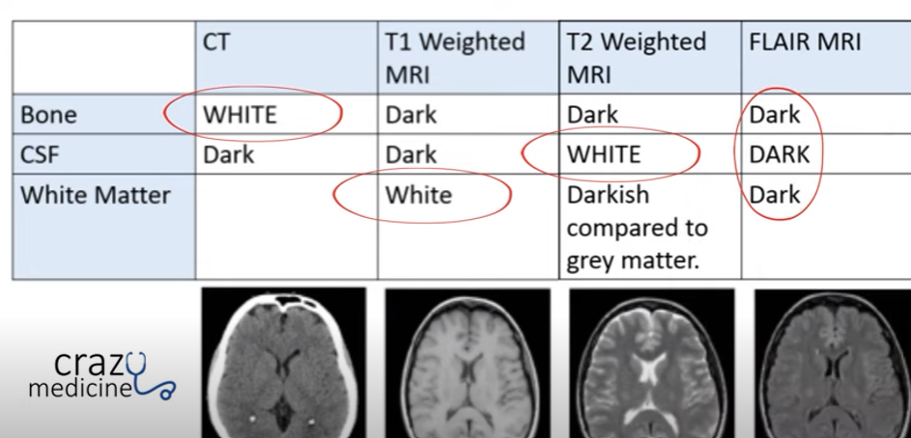

**Artifacts in MR Imaging:**

- Chemical shift causes material-dependent frequency deviations, particularly apparent in ultrafast sequences like EPI.

- Ghosting occurs due to phase encoding inaccuracies or patient movement.

- Shading results from RF signal attenuation and magnetic field inhomogeneity.

- Noise and partial volume effects (PVE) cause image artifacts similar to CT imaging.

- Metal artifacts from paramagnetic materials can cause signal deletion.

**MR Angiography:**

Contrast Enhancement: MR angiography (MRA) can be enhanced using gadolinium contrast agents, resulting in high-contrast images of blood vessels.

Image Presentation: MRA images are commonly displayed as maximum intensity projection (MIP) images, which highlight the maximum intensity of the contrast-enhanced vessels for better visualization.

**BOLD Imaging:**

- Blood Oxygen Level Dependency (BOLD) Imaging detects local magnetic field distortions caused by deoxygenated hemoglobin.

- BOLD imaging can be used to measure brain activity by correlating intensity changes with tasks performed by the subject.

**Perfusion Imaging:**

Perfusion Measurement: Gadolinium-enhanced MRI is utilized to measure perfusion by assessing changes in blood volume and flow.

Diagnostic Applications: Perfusion imaging aids in diagnosing stroke and analyzing blood flow in conditions such as tumors or cardiac studies.

**Diffusion Imaging:**

Diffusion Coefficient Measurement: Diffusion imaging evaluates the diffusion coefficient of isotropic or anisotropic diffusion, indicating changes in tissue.

Diffusion Tensor Imaging (DTI): DTI specifically tracks fiber direction in the brain, enabling MR tractography to reconstruct brain connections.

**Image Analysis on Magnetic Resonance Images:**

- MRI provides better soft tissue contrast but lacks standardized image intensity measurements.

- Image appearance can vary based on sequence type, scanner type, and acquisition parameters.

- Artifacts like shading and noise can complicate tissue-to-image brightness mapping and affect image analysis methods.

**Ultrasound Imaging:**

- Ultrasound waves are reflected at boundaries between materials with different acoustic impedance, allowing for imaging of organ boundaries.

- Reflections can be reconstructed based on the speed of sound in the tissue.

- Ultrasound imaging utilizes a transducer to send and receive ultrasound waves.

- Diagnostic ultrasound frequencies typically range between 1 and 20 MHz.

- High-frequency waves attenuate faster and penetrate the body less effectively than low-frequency waves.

1. **Ultrasound A-Scan:**
   * A single ultrasound wave is sent into the body and records the amplitude of reflections over time.
   * It provides a one-dimensional probe into the body, showing tissue boundaries and other regions with different acoustic impedance.
2. **Ultrasound B-Scan:**
   * Ultrasound images (B-scans) are created from a planar fan beam of differently rotated A-scans.
   * Amplitudes are mapped to gray values to create the image, which can also be acquired as 3D images with the fan beam rotating around a perpendicular axis.

**Ultrasound Imaging Applications:**

- Ultrasound imaging, or sonography, can show real-time motion of internal organs.

- Organs commonly imaged include the liver, gallbladder, pancreas, kidneys, spleen, heart, and uterus.

- Techniques like transesophageal ultrasound (placing the device into the esophagus) and transrectal ultrasound (placing the device into the rectum) enable imaging of specific organs.

- Intravascular ultrasound (IVUS) involves inserting the device into arteries to image and quantify calcifications.

**Doppler Imaging:**

- Utilizes the Doppler effect to estimate the speed and direction of moving objects (e.g., blood) in ultrasound images.

- Helps diagnose vessel blockages or changes in blood flow due to stenosis.

- Color-coded velocity depictions differentiate between flow directions and velocities.

**FUS Imaging:**

- Focused ultrasound (FUS) can be used in image-guided therapy to increase energy at a specific point, such as thermal ablation of tumors.

- FUS may also induce mechanical effects or stimulate growth in various body regions, but it requires substantial support during intervention.

**Artifacts in Ultrasound Imaging:**

- Various effects cause artifacts in ultrasound images, including attenuation, absorption, scattering, refraction, interference, and wave divergence.

- Absorption leads to decreased amplitude with depth, while interference, scatter, and refraction cause speckle artifacts.

- Tissue boundaries may produce mirror echoes or multiple echoes, and motion artifacts can distort boundaries.

- Acoustic shadowing may hide tissues, while fluid-induced signal enhancement can lead to position-dependent signal increases.

- Absorption decreases the signal-to-noise ratio with increasing distance from the transducer.

**Image Analysis on Ultrasound Images:**

- Ultrasound is noninvasive and inexpensive, making it widely used for diagnosis.

- Artifacts and underlying assumptions can affect quantitative analysis, including localization errors due to variations in the speed of sound and displacement errors from refraction.

- Organ boundaries, motion artifacts, and acoustic shadowing can also impact analysis.

- Absorption affects the signal-to-noise ratio based on distance from the transducer.

**Nuclear Imaging:**

- Measures radioactive tracer distribution in the body for functional imaging.

- Tracer material is injected intravenously, distributing through blood circulation.

- Applications include brain activity, heart perfusion, inflammation diagnosis, and tumor detection.

- Images formed by measuring photons emitted by tracer material.

- Lower spatial resolution due to low tracer concentration.

- High sensitivity allows detection of signals from few photons.

**Major Techniques:**

- Scintigraphy: Projects tracer distribution similar to X-ray imaging.

- SPECT (Single Photon Emission Computed Tomography): 3D reconstruction from tracer projections.

- PET (Positron Emission Tomography): Utilizes positron-emitting tracer materials for imaging.

1. **Scintigraphy:**
   1. Uses 99Tc tracer molecule detected by a gamma camera.
   2. Camera includes a collimator, scintillator crystal, and photomultipliers.
   3. Collimator provides approximate parallel projection of tracer photons.
   4. Limitations in spatial resolution and contrast due to collimator characteristics.
2. **SPECT:**
   1. Reconstruction from gamma camera projections.
   2. Spatial resolution approximately 3-6 mm.
   3. Acquisition with single or multi-head cameras.
   4. Applications include heart perfusion, tumor detection, and brain studies.

**Image Analysis:**

- Signal strength depends on tracer amount and metabolism.

- Quantitative measurements usually compare activity between regions.

- Poor image quality due to low photon count and acquisition restrictions.

- Often requires correlation of functional signal with anatomy.

**Other Imaging Techniques:**

* 1. Optical Coherence Tomography: Utilizes light waves for imaging, useful in ophthalmology and dermatology.
  2. Photography: Used for vascular processes in retina and diagnosis of skin tumors.
  3. Optical Microscopy: Analyzes living structures, often used for pathology diagnosis.
  4. Electron Microscopy: Higher resolution imaging using electron detection.
  5. EEG and MEG: Measures brain activity through electrical or magnetic impulses.